# Week1 – Html and CSS Instructions for Task1 Name: Jeshma Ullas

## **HTML Task**

### List Example:

* Open index.html in your IDE.
* Locate the "List Example" section.
* Added <ul> under the existing <ol>..</ol>.
* Inside the <ul>, add list items (<li>) as needed with square bullet style.

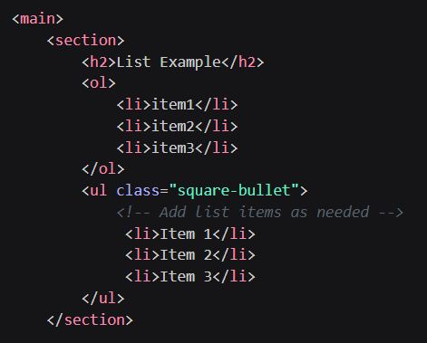

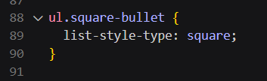

### Table Example:

* Find the "Table Example" section in index.html.
* Update the table to include a new row (<tr>) after the existing rows.
* In this new row, add a single <td> element that spans across both columns (colspan="2").

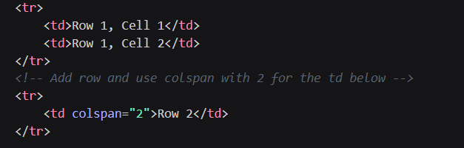

### Navigation Example:

* Navigate to the "Navigation Example" section in index.html.
* Add hyperlinks for navigating to page1.html and page2.html.
* Use descriptive text such as "SamplePage1" and "Visit SamplePage2" for the hyperlinks.

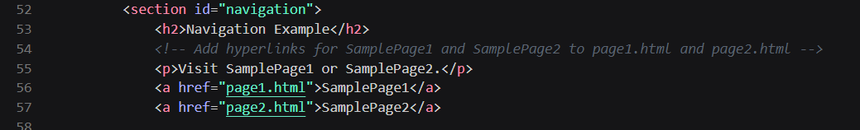

### Form Example:

* Locate the "Form Example" section in index.html.
* Enhance the existing form by adding a new input field for the user's phone number along with label as **Phone**
* Include a corresponding <label> for this new input field.

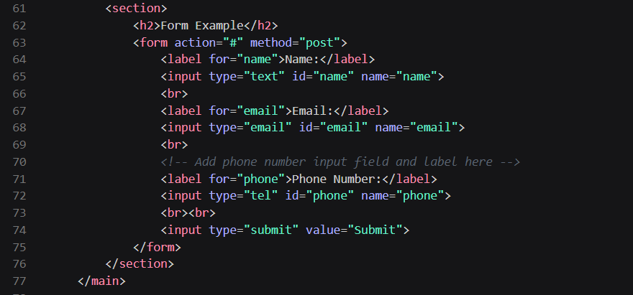

## **CSS Task**

**Note:** After completing each CSS task, remember to save your changes in styles.css and then refresh your webpage (index.html) in your browser.

### Header styles:

* Open styles.css in your IDE
* Apply dark background color #333 and text color #fff to the header (header).
* Center align the text and add padding of 10px within the header

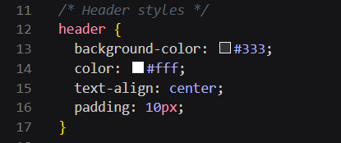

### Main Content Styles:

* Set padding of 20px for the main section.

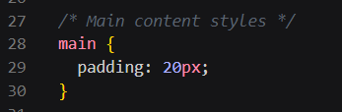

### Form Input Styles

* Select and style <input> elements of types text, email, and tel.
* Ensure these inputs have a width of calc(100% - 22px) to accommodate padding and borders, a padding of 10px, margin of 5px 0 10px, a 1px solid border with #ccc color, border-radius of 4px, and include padding and border in the total width (box-sizing: border-box).

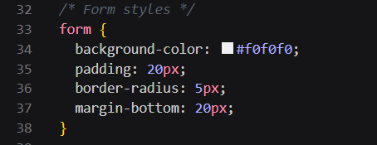

### Footer Styles:

* Include a dark background color #333, text color #fff, centered text alignment, 10px padding, fixed position at the bottom (position: fixed), full width (width: 100%) and add bottom: 0 to keep it at the very bottom of the page.

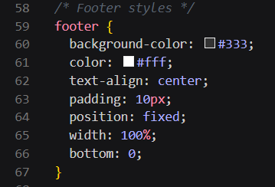

### Enhanced Task - Input Submit Button Styles

* Find the section labeled **"Enhanced Task: Input Submit Button styles"**.
* Uncomment the CSS properties/rules for input[type="submit"] and input[type="submit"]:hover



 

